**23CSE113**

**USER INTERFACE DESIGN**

**LAB REPORT**



**Department of Computer Science Engineering**

**Amrita School of Computing**

**Amrita Vishwa Vidyapeetham, Amaravati Campus**

**Verified By: Name: K .BHAVAGNYA**

**Roll No: AV.SC.U4CSE24209**

**WEEK-1:**

**1.Create your class timetable.**

<html>

<body>

    <style>

       table{

        .glimpses {

            background-color: rgb(217, 58, 222);}

        .advisor {

            background-color: rgb(252, 94, 162);}

        .break {

            background-color: rgb(218, 139, 186);}

        .library {

            background-color: rgb(223, 155, 223);}

       }

    </style>

    </style>

    <table width="1000" border="1" cellpadding="10" cellspacing="0">

    <tr>

        <th>Time/Day</th>

        <th>Slot 1 (08:55am to 09:45am)</th>

        <th>Slot 2 (09:45am to 10:35am)</th>

        <th>(10:35am to 10:45am)</th>

        <th>Slot 3 (10:45am to 11:35am)</th>

        <th>Slot 4 (11:35am to 12:25pm)</th>

        <th>Slot 5 (12:25pm to 01:15pm)</th>

        <th>(01:15pm to 02:05pm)</th>

        <th>Slot 6 (02:10pm to 03:00pm)</th>

        <th>(03:00pm to 03:10pm)</th>

        <th>Slot 7 (03:10pm to 04:00pm)</th>

        <th>Slot 8 (04:00pm to 04:50pm)</th>

    </tr>

    <tr>

        <td>MONDAY</td>

        <td>23CSE111 Object Oriented Programming</td>

        <td>23MEE115 Modern Physics</td>

        <td rowspan="5" class="special"><b>SHORT BREAK(10:35am to 10:45am)</b></td>

        <td colspan="2" class="special">23MAT117 Linear Algebra Lab(BYOD)</td>

        <td class="library">Library/Seminar/Sports</td>

        <td rowspan="5" class="special"><b> LUNCH BREAK</b></td>

        <td>23MAT116 Discrete Mathematics</td>

        <td rowspan="5" class="special"><b>SHORT BREAK</b></td>

        <td class="library">Library/Seminar/Sports</td>

        <td class="library">Library/Seminar/Sports</td>

    </tr>

    <tr>

        <td>TUESDAY</td>

        <td>23CSE113 User Interface Design</td>

        <td class="library">Library/Seminar/Sports</td>

        <td colspan="3" class="special">23MEE115 Manufacturing Practice Lab</td>

        <td>23MAT117 Linear Algebra </td>

        <td class="glimpses">22ADM111 Glimpses of Glorious India</td>

        <td class="library">Library/Seminar/Sports</td>

    </tr>

    <tr>

        <td>WEDNESDAY</td>

        <td>23MAT117 Linear Algebra</td>

        <td>23MEE115 Modern Physics</td>

        <td colspan="2" class="special">23MAT116 Discrete Mathematics Lab (BYOD/ Lab 2)</td>

        <td>23CSE113 User Interface Design</td>

        <td>23CSE111 Object Oriented Programming</td>

        <td class="advisor">Class Advisor/Counsellor</td>

        <td class="library">Library/Seminar/Sports</td>

    </tr>

    <tr>

        <td>THURSDAY</td>

        <td class="glimpses">22ADM111 Glimpses of Glorious India</td>

        <td>23MAT116 Discrete Mathematics</td>

        <td colspan="2" class="special">23CSE113 User Interface Design Lab(BYOD)</td>

        <td>23CSE111 Object Oriented Programming</td>

        <td class="library">Library/Seminar/Sports</td>

        <td class="library">Library/Seminar/Sports</td>

        <td class="library">Library/Seminar/Sports</td>

    </tr>

    <tr>

        <td>FRIDAY</td>

        <td>23MAT116 Discrete Mathematics</td>

        <td class="library">Library/Seminar/Sports</td>

        <td colspan="2" class="special">23CSE111 Object Oriented Programming Lab(Lab1)</td>

        <td>23MAT117 Linear Algebra</td>

        <td>23MEE115 Modern Physics</td>

        <td class="glimpses">22ADM111 Glimpses of Glorious India</td>

        <td class="library">Library/Seminar/Sports</td>

    </tr>

</html>

</body>

**OUTPUT:-**

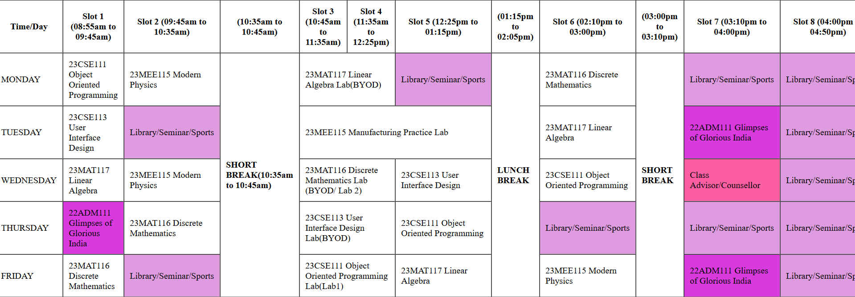

**WEEK-2:**

**2.Make a registration form:**

<html>

<head>

<title>Forms</title>

</head>

<h1 align="center">REGISTRATION FORM</h1>

<Form>

    <table border="4" align="center" bgcolor=violet width="500" cellspacing="0">

        <tr>

                <tr>

                    <td><p> First Name:</td><td><input type="text"></p></td></tr>

                    <td><p> Last Name:</td><td><input type="text"></p></td></tr>

                    <tr><td>Age:</td><td><input type="text"></td></tr>

                    <tr><td>Password:</td><td><input type ="password"></td></tr>

                    <tr><td>Email:</td><td><input type="text"></td></tr>

                    <tr>

                        <td><P>DoB</P></td>

                        <td><input type="date"></td>

                    </tr>

                        </P></td>

                    </tr>

                    <tr><td>Gender:</td>

                    <td>

            <input type="radio" name="gender">Female<br>

            <input type="radio" name="gender">Male<br>

            </td>

                    </tr>

            <tr><td>Hobbies:</td>

                <td>

            <input type="checkbox" name="read">Reading

            <input type="checkbox" name="paint">Painting

            <input type="checkbox" name="travel">Travelling

        </td>

    </tr>

        <tr><td><p>Branch:</td><td><select name = "branch">

            <option value = " ">Select</option>

            <option value = "CSE">CSE</option>

            <option value = "CSE-AI">CSE-AI</option>

            <option value = "CCE">CCE</option></select></td></p></td></tr>

            <tr><td><p>Time:</td><td><input type = "time" name = "time"></td></p></tr>

           </tr>

        <br><br>

        <tr><td>Upload File</td>

            <td>

                <input type="file" name="file name">

            </td>

            <br><br>

        <tr><td>Rating</td>

            <td>

                <input type="range" name="range value=">

            </td>

            <br>

            <br>

            <tr><td><p>Select color:</td><td><input type = "color" name = "color"></td></p></tr>

            <tr><td><p>Address:</td><td><textarea rows = 10 cols = 22></textarea></td></p></tr>

            <tr><td><p>Write a description of yourselves:</td><td><textarea rows = 10 cols = 22></textarea></td></p></tr>

            <tr><td><input type = "button" value = "Submit">

            <input type = "button" value = "Reset"></td></tr>

            <tr>

        </form>

        </body>

</html>

**OUTPUT:  
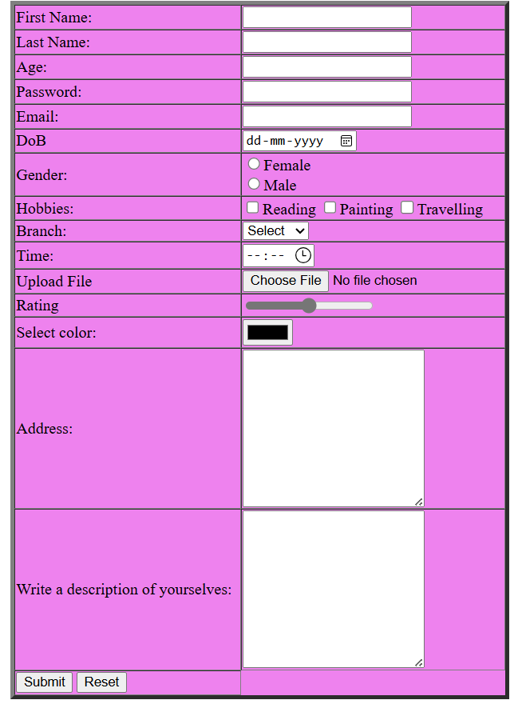**

**WEEK-3:**

**3.Create Amrita University website**